**Project Report**

on

**JAVA**

Submitted To: Submitted by:

Mrs. Prajakta Patil Arpit Porwal

Amit Agarwal

Tushar Gupta

**TABLE OF CONTENTS**

Page No

*Acknowledgement i*

*Abstract ii*

1

1

2

2

2

2

3

4

6

7

1. ABOUT PROJECT…………………………………………………………………
   1. Introduction……………………………………………………………
2. LANGUAGE………………..………………………………………………
   1. Introduction………………………………………………………………
   2. Naming Conventions…………………………………………………….
   3. Advantages………………………………………………………………
3. REQUIREMENT SPECIFICATIONS………………………………………
4. SNAPSHOTS………………………………………………………………..

CONCLUSION………………………………………………….………………

REFERENCES………………………………………………………………….

**Chapter 1: ABOUT PROJECT**

**1.1 Introduction**

Health is one of the biggest problem in India. According to a latest survey of United Nations, we are behind Pakistan in terms of Doctors available in the country per 1000 people.

According to the Global Burden of Disease Study (GBD) published in the medical journal The Lancet, India was ranked 154th among 195 countries on the healthcare index.

And it’s a great paradox for India that We can now fire an Agni V to destroy our most capable enemies, but our citizens cannot diagnose their disease at first place.

We are conceptualizing and executing the cheapest journeys to Mars, but our girls fail to successfully complete the journey from mothers’ wombs to the birth table.

When it comes to diagnosis of disease at an earlier stage, most of the people ignore it due lack of health facilities at their place, both physically and technologically.

This ignorance of disease leads to a catastrophe at the later stage of the disease.

So to bridge this gap between people and health, I came up with a technological solution to it named **SWASTH**

I have built a system wherein we have an ecosystem for all the users. Our panel has following features:

* Tips for Healthy life
* Detection of disease of the basis of symptoms
* Nearby doctors available with their contact information

Coding of the “Book-Store” presented in this project is done by using JAVA in eclipse.

**Chapter 2: LANGUAGE**

**2.1 Introduction**

Java is a general purpose, [high-level programming language](http://www.webopedia.com/TERM/H/high_level_language.html) developed by [Sun Microsystems](http://www.webopedia.com/TERM/S/Sun_Microsystems.html). The Java programming language was developed by a small team of engineers, known as the Green Team, who initiated the language in 1991. The language was originally called OAK, and at the time it was designed for handheld devices and set-top boxes. Oak was unsuccessful and in 1995 Sun changed the name to Java and modified the language to take advantage of the burgeoning [World Wide Web](http://www.webopedia.com/TERM/W/World_Wide_Web.html).

Java is defined as an [object-oriented language](http://www.webopedia.com/TERM/O/object_oriented_programming_OOP.html) similar to [C++](http://www.webopedia.com/TERM/C/C_plus_plus.html), but simplified to eliminate language features that cause common programming errors. The [source code](http://www.webopedia.com/TERM/S/source_code.html) files (files with a .java extension) are [compiled](http://www.webopedia.com/TERM/C/compile.html) into a format called byte code (files with a .class extension), which can then be executed by a Java [interpreter](http://www.webopedia.com/TERM/I/interpreter.html). Compiled Java code can run on most computers because Java interpreters and [runtime](http://www.webopedia.com/TERM/R/runtime.html) environments, known as Java Virtual Machines (VMs), exist for most [operating systems](http://www.webopedia.com/TERM/O/operating_system.html), including [UNIX](http://www.webopedia.com/TERM/U/UNIX.html), the [Macintosh](http://www.webopedia.com/TERM/M/Macintosh_computer.html) OS, and [Windows](http://www.webopedia.com/TERM/W/Windows.html).

**2.2 Naming Conventions**

Naming Conventions must be followed while developing software in java for good maintenance and readability of code. Java uses Camel Case as a practice for writing names of methods, variables, classes, packages and constants.

**Camel case in Java Programming:** It consists of compound words or phrases such that each word or abbreviation begins with a capital letter or first word with a lowercase letter, rest all with capital.

1. Classes and Interfaces:
2. Class names should be nouns, in mixed case with the first letter of each internal word capitalized. Interfaces name should also be capitalized just like class names.
3. Use whole words and must avoid acronyms and abbreviations.
4. Methods: Methods should be verbs, in mixed case with the first letter lowercase and with the first letter of each internal word capitalized.
5. Variables: Variable names should be short yet meaningful.
6. Should not start with underscore (‘_’) or dollar sign ‘$’ characters.
7. Should be mnemonic i.e., designed to indicate to the casual observer the intent of its use.
8. One-character variable names should be avoided except for temporary variables.
9. Common names for temporary variables are i, j, k, m, and n for integers; c, d, and e for characters.
10. Constant variables:
11. Should be all uppercase with words separated by underscores (“_”).
12. There are various constants used in predefined classes like Float, Long, String etc.
13. Packages:
14. The prefix of a unique package name is always written in all-lowercase ASCII letters and should be one of the top-level domain names, like com, edu, gov, mil, net, org.
15. Subsequent components of the package name vary according to an organization’s own internal naming conventions.

**2.3 Advantages**

## Few of the advantages of Java Programming Language are:

* **Platform Independence :** Java is platform independent, which means that if a program is written and compiled in Java on any platform(underlying hardware and software), it can run on any other platform of similar capabilities subjected to available hardware (computing power, memory and disk space) and software(installed JRE) requirements.
* **Automatic Storage Management :** This is done using a garbage collector, which avoids the safety problems of explicit de-allocations. This means that a programmer need not call the destructor (as in C/C++) to explicitly de allocate the memory used by an the structures or objects.
* **Avoids Unsafe Constructs:** In Java arrays are accessed after explicitly doing an index check on the bounds of the array. It throws an “ArrayIndexOutOfBoundexception” in case the program tries to access an index which is not within the range of the array.
* **No explicit declaration order required:** It does not require types (Classes or Interfaces) or their members (fields and methods) to be declared before they are used. It only becomes significant when we declare local variables, local classes and the order of initializers of fields in a class or interface. All other variables are automatically initialized to a default value; the Java programming language does not automatically initialize local variables.
* **Type Safety:**Java is a safe programming language because of its static typed and strongly typed nature. **Statically typed** means every variable is declared and has a type and the type is known at the compile time. **Strongly typed** means that a variable can only be assigned a set of values which are compatible with the type of the variable. This also helps in identifying most of the errors at compile time and clearly distinguishes them with the runtime errors.
* **Exception Handling Support:**Java has defined an Exception Hierarchy and has a great support for Exception Handling. This offers a lot of robustness and helps the developers to handle compile time exceptions without fail and write a defensive program.
* **Multi-threading Support:** Java encapsulates the underlying system’s thread infrastructure and offers a great and easy support for multi threading. There is no explicit need of writing a monitor code for acquiring locks on objects. Java also makes it easy to create multiple threads and execute independent tasks with the help of Thread Pools.

**Chapter 3: REQUIREMENT SPECIFICATIONS**

In this project, we have done JAVA coding Eclipse. To run java on eclipse you have to install java in your system. You also have to set environment variables such that Windows can find the Java compiler and interpreter.

Environment variables are a set of dynamic named values that can affect the way running processes will behave on a computer. They are part of the environment in which a process runs.

By using certain commands user can enter the desire input and get the output accordingly.

Eclipse is very easy to use and debug errors.

Netbeans is also one of the software that you can use to write a code in java.

We have used XAMMP server to access mysql facilities.

**Chapter 4: SNAPSHOTS**

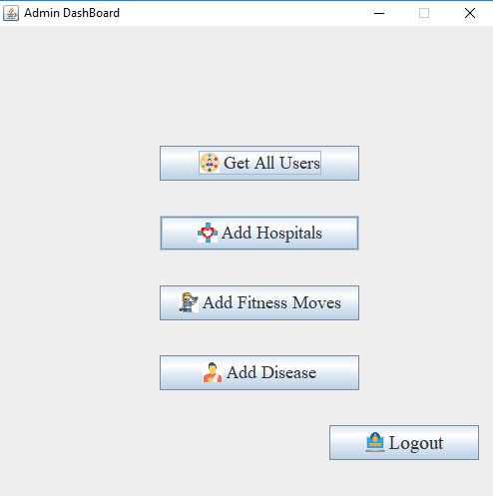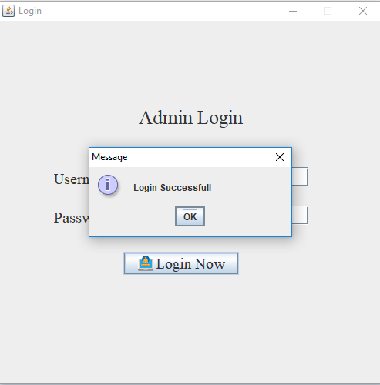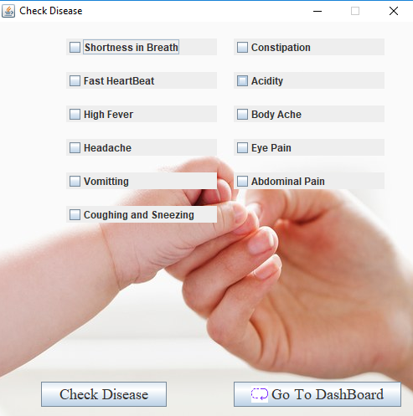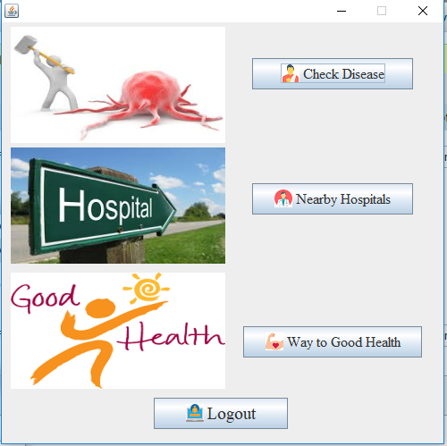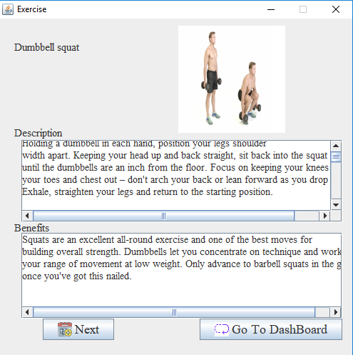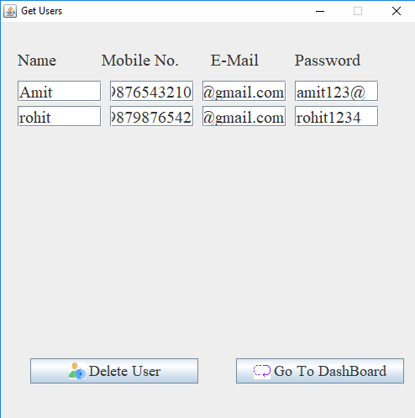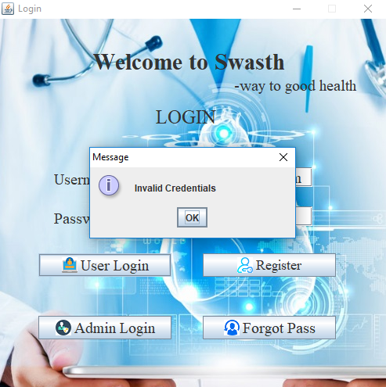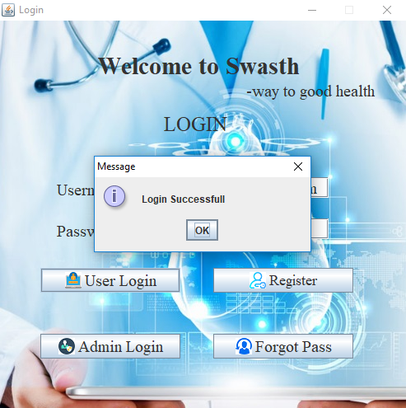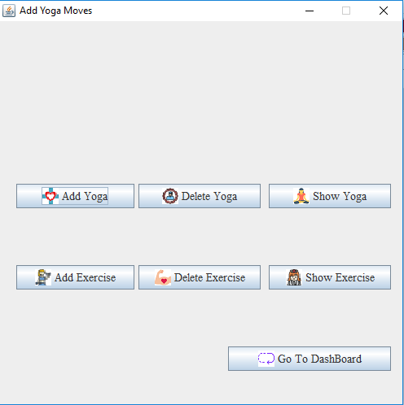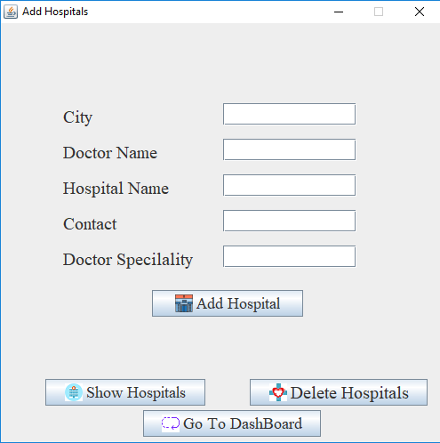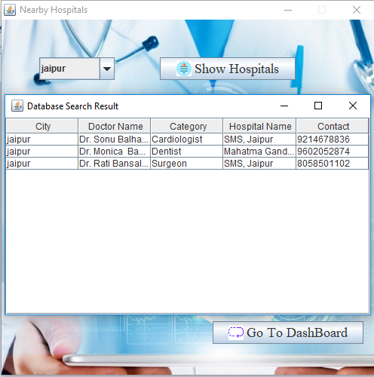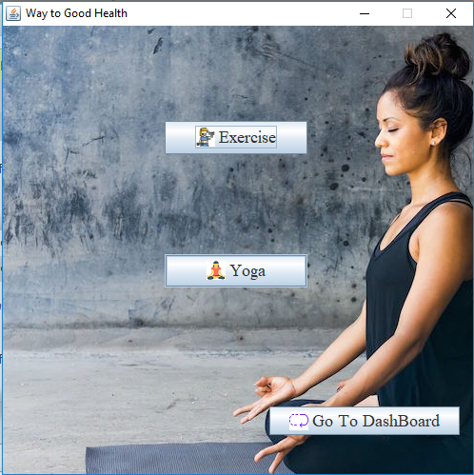

**CONCLUSION**

The purpose of this report is to code an application i.e. SWASTH

As the name implies, Swasth is to provide a platform to the user to get a one stop solution to all medical things.

In this project, we have coded a stand-alone application in which we have added some features like get nearby doctors, diagnose your disease on the basis of your symptoms and a section of way to healthy life which include yoga, meditation and gym tips.

Coding of the “SWASTH” presented in this project is done by using JAVA in eclipse.

**REFERENCES**

* http://introcs.cs.princeton.edu/java/15inout/windows-cmd.html
* <https://yellowpages.webindia123.com/o-d/Rajasthan/Jaipur/2/1/>
* http://www.un.org/en/sections/issues-depth/health/index.html
* <https://www.javatpoint.com/>
* <https://www.wikihow.com/Get-Fit-in-the-Gym>
* https://www.wikihow.com/Enjoy-Yourself-at-the-Gym